# Unit 5 – Lesson 2. Finite State Machine and Transition Matrix of the Markov Process

***Aim:*** What is Markov Chain?

**Objectives:** After the lesson, students should be able to:

* Obtain understanding of Markov property and Markov chain
* Explain Markov chain using examples

***References:***

* Unity 5.x Game AI Programming Cookbook, Palacios
* Duke University, Introduction to Machine Learning, Markov Chain
* CMU, Machine Learning
* Other wonderful online images and simple examples

**CLASS PROCEDURE:**

***Do Now:***

Assume there are only two drinks available for purchase – Coke and Pepsi.

* Given a person’s last purchase of drink was Coke, there is a 90% chance that his next purchase of drink will also be Coke.
* If a person’s last purchase was Pepsi, there is an 80% chance that his next purchase will also be Pepsi.

Given that a person is currently a Pepsi purchaser, what is the probability that he will purchase Coke two purchases from now?

***Class Discussion / Presentation:***

1. **What is the Markov Chain?**
2. Markov Chains is a probabilistic process, that relies on the current state to predict the next state.
3. For Markov chains to be effective the current state has to be dependent on the previous state in some way; For instance, from experience we know that if it looks cloudy outside, the next state we expect is rain. We can also say that when the rain starts to subside into cloudiness, the next state will most likely be sunny.
4. Not every process has the Markov Property, such as the Lottery, this weeks winning numbers have no dependence to the previous weeks winning numbers.

According to wiki, here’s the definition of Markov Chain and Markov Process:

* In [probability theory](https://en.wikipedia.org/wiki/Probability_theory) and related fields, a **Markov process** (or **Markoff process**), named after the [Russian](https://en.wikipedia.org/wiki/Russia) mathematician [Andrey Markov](https://en.wikipedia.org/wiki/Andrey_Markov), is a [stochastic process](https://en.wikipedia.org/wiki/Stochastic_process) that satisfies the [Markov property](https://en.wikipedia.org/wiki/Markov_property)[[1]](https://en.wikipedia.org/wiki/Markov_chain#cite_note-Serfozo2009page2-1)[[2]](https://en.wikipedia.org/wiki/Markov_chain#cite_note-Rozanov2012page58-2) (sometimes characterized as "[memorylessness](https://en.wikipedia.org/wiki/Memorylessness" \o "Memorylessness)").
* Loosely speaking, a process satisfies the Markov property if one can make predictions for the future of the process based solely on its present state just as well as one could knowing the process's full history, hence independently from such history; i.e., [conditional](https://en.wikipedia.org/wiki/Conditional_probability) on the present state of the system, its future and past states are [independent](https://en.wikipedia.org/wiki/Independence_(probability_theory)).
* A **Markov chain** is a type of Markov process that has either discrete [state space](https://en.wikipedia.org/wiki/State_space) or discrete index set (often representing time), but the precise definition of a Markov chain varies.[[3]](https://en.wikipedia.org/wiki/Markov_chain#cite_note-Asmussen2003page73-3)
* For example, it is common to define a Markov chain as a Markov process in either [discrete or continuous time](https://en.wikipedia.org/wiki/Continuous_and_discrete_variables) with a countable state space (thus regardless of the nature of time),[[4]](https://en.wikipedia.org/wiki/Markov_chain#cite_note-Parzen1999page1882-4)[[5]](https://en.wikipedia.org/wiki/Markov_chain#cite_note-KarlinTaylor2012page292-5)[[6]](https://en.wikipedia.org/wiki/Markov_chain#cite_note-Lamperti1977chap62-6)[[7]](https://en.wikipedia.org/wiki/Markov_chain#cite_note-Ross1996page174and2312-7) but it is also common to define a Markov chain as having discrete time in either countable or continuous state space (thus regardless of the state space).[[3]](https://en.wikipedia.org/wiki/Markov_chain#cite_note-Asmussen2003page73-3)

Here’s a picture of Markov:

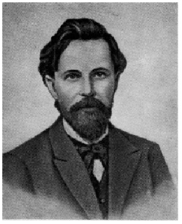

1. **Markov property and models are widely used in natural language processing, speech recognition, image processing, financial market forecasting, and machine learning.**
2. **What is the diagram for Markov process?**

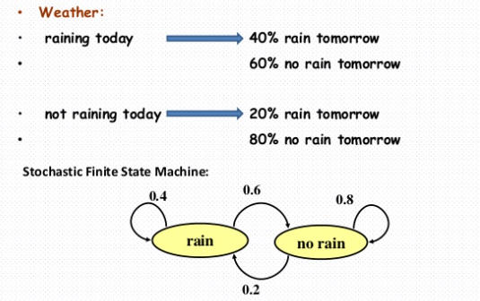

1. **What is the transition matrix of the Markov process?**

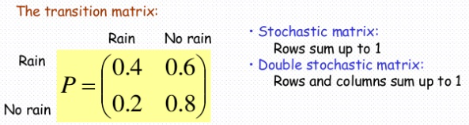

1. **How do we use the transition matrix to solve problems?**

Using the “Do Now” as an example,

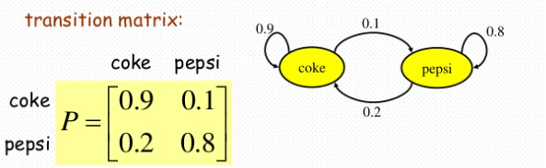

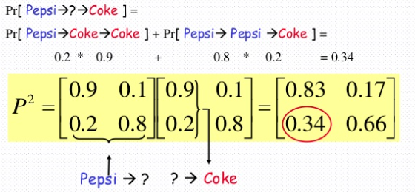

***Pair – sharing Activity / HW:***

